Sermon Notes
Topic: “God Deserves and Defines Worship”
Speaker: Dave White
Sermon Text: Deuteronomy 12-16:17
Notes:___________________________________________________________________________________________________________________________________________________________________________________________________________________________________________________________________________________________________________________________________________________________________________________________________________________________________________________________________________________________________________________________________________________________________________________________________________________________________________________________________________________________________ ________________________________________________________________________________________________________________________________________________________________________________________________________________________________________________________________________________________________________________________________________________________________________________________________________________________________________________________________________________________________________________Weekly Prayer Requests:
_________________________________________________________________________________________________________________________________________________________________________________________________________________________________________________________

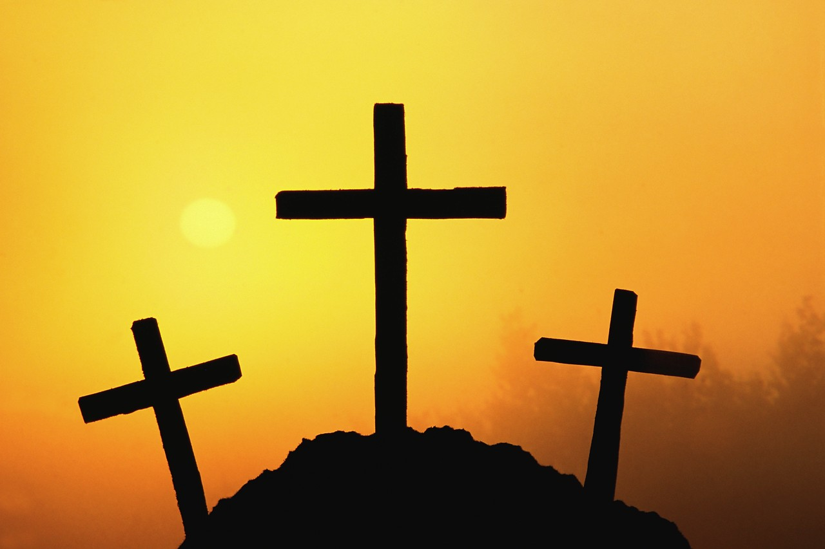

Redeemer Presbyterian
Church of Buena Vista
Meeting at Darren Patterson Christian Academy

Sunday, June 24th, 2012
9:15-9:45 Sunday School
10:15 Worship Service

Apostles’ Creed

I believe in God, the Father almighty,
creator of heaven and earth.

I believe in Jesus Christ, his only Son, our Lord,
who was conceived by the Holy Spirit
and born of the virgin Mary.
He suffered under Pontius Pilate,
was crucified, died, and was buried;
he descended to hell.
The third day he rose again from the dead.
He ascended to heaven
and is seated at the right hand of God the Father almighty.
From there he will come to judge the living and the dead.

I believe in the Holy Spirit,
the holy catholic church,
the communion of saints,
the forgiveness of sins,
the resurrection of the body,
and the life everlasting. Amen.

The Apostles’ Creed is the oldest creed, and lies at the basis of most others. Though not, as the long-current legend of its origin affirmed, the direct work of the Apostles, it has its roots in apostolic times, and embodies, with much fidelity, apostolic teaching. It will be seen immediately that it had an important place in the early church, when as yet no creed but itself existed. The oldest usage of the term “Rule of Faith” (regula fidei), now commonly given to the Scriptures, has reference to this creed. It was the creed that could be appealed to as held by the church in all its great branches, and so as forming the test of catholicity. It was as resting on this creed that the church could be called “catholic and apostolic.” Of late the creed has been the subject of great controversy, and violent attempts have been made to thrust out some of its chief articles from the Christian faith. This is a special reason for considering the foundations on which these articles of faith rest.

From: International Standard Bible Encyclopedia Vol. 1
Author: James Orr

Sunday June 24th, 2012
Order of Worship
*Call to Worship Psalm 100

*Hymn 55 “To God Be the Glory”
*Hymn 499 “Rock of Ages” *Hymn 629 “What a Friend We Have in Jesus”
Congregational Prayer

Corporate Confession of Sin
Almighty and most merciful Father, we are thankful that your mercy is higher than the heavens, wider than our wanderings, deeper than all our sin. Forgive our careless attitudes toward your purposes, our refusal to relieve the suffering of others, our envy of those who have more than we have, our obsession with creating a life of constant pleasure, our indifference to the treasures of heaven,
our neglect of your wise and gracious law. Help us to change our way of life
so that we may desire what is good, love what you love, and do what you command, through Jesus Christ our Lord. Amen.

Declaration of Pardon from God’s Word Acts 13:38-39

*The Apostles’ Creed

*Scripture Reading Deuteronomy 12:1-4
(NASB) “These are the statutes and the judgments which you shall carefully observe in the land which the Lord, the God of your fathers, has given you to possess as long as you live on the earth. You shall utterly destroy all the places where the nations whom you shall dispossess serve their gods, on the high mountains and on the hills and under every green tree. You shall tear down their altars and smash their sacred pillars and burn their Asherim with fire, and you shall cut down the engraved images of their gods and obliterate their name from that place. You shall not act like this toward the Lord your God
Sermon “God Deserves and Defines Worship”
Dave White
Communion
*Benediction 1 Thessalonians 5:23

*Please Stand if you are able
An offering basket is located at the back of the room for your tithes and offerings

